21BDS0340

Abhinav Dinesh Srivatsa

BCSE101E, VL2021220107100 – TC2 (Theory) BCSE101E, VL2021220107101 – L15+L16+L29+L30 (Lab)

# Question 1: Write a PAC chart, flowchart, and algorithm, for Complex calculator to find addition, subtraction, multiplication, division of given two complex numbers.

## PAC:

|  |  |  |  |
| --- | --- | --- | --- |
| **Data** | **Processing** | **Output** | **Alternative Solutions** |
| Complex1 = Read Input Complex2 = Read Input | Sum = Complex1 + Complex2 Diff = Complex1 – Complex2 Prod = Complex1 * Complex2 Quot = Complex1 / Complex2 | Sum Diff Prod Quot | Define Complex1 and Complex2 |

Flowchart:

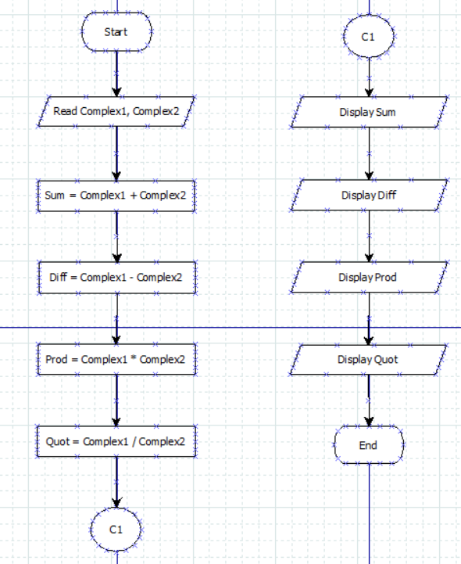

Algorithm:

Read Complex1, Complex2

Calculate Sum = Complex1 + Complex2 Calculate Diff = Complex1 – Complex2 Calculate Prod = Complex1 * Complex2 Calculate Quot = Complex1 / Complex2 Display Sum

Display Diff Display Prod Display Quot

Code:

complex1 = complex(input())

complex2 = complex(input())

sum = complex1 + complex2

diff = complex1 - complex2

prod = complex1 * complex2

quot = complex1 / complex2

print(sum)

print(diff)

print(prod)

print(round(quot.real, 2) + round(quot.imag, 2) * 1j)

# Question 2: Write a PAC chart, flowchart, and algorithm, for generating Resort bill. A famous resort in Ooty charges 3000 Rs per day for single person, 4000 Rs per day for double person . Take values from user: number of people, number of days to stay, generate a bill accordingly. If customer wants to include breakfast as a combo, then additional 500 Rs per day per head will be charged.

## PAC:

|  |  |  |  |
| --- | --- | --- | --- |
| **Data** | **Processing** | **Output** | **Alternative Solutions** |
| People = Read Input Days = Read Input Breakfast = Read Input  Sum = 0 | If People is even, then add People * 4000  / 2 to Sum  Else add People * 4000 // 2 + 3000 to Sum  If Breakfast = 1, then add 500 to Sum  Sum = Days * Sum (for multiple days) | Sum | Define People, Days, Breakfast |

Flowchart:

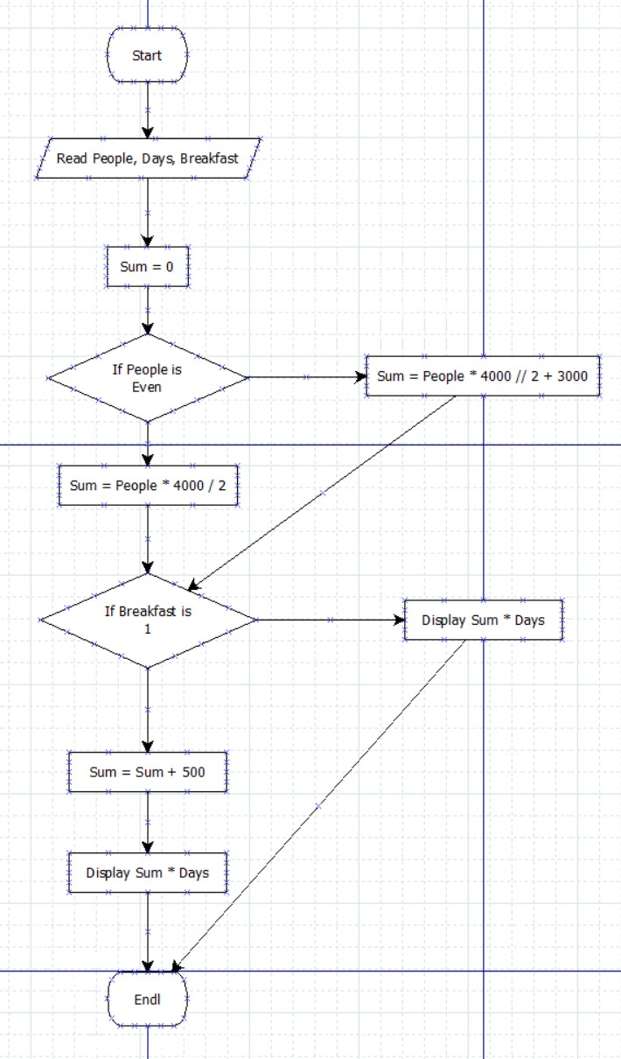

## Algorithm:

Read People, Days, Breakfast Initialise Sum = 0

If People is even, then

Calculate Sum = People * 4000 / 2 Else calculate Sum = People * 4000 // 2 + 3000 If Breakfast = 1, then

Calculate Sum = Sum + 500 Display Sum * Days

Code:

people = int(input())

days = int(input())

breakfast = int(input())

sum = 0

if people < 0 or days < 0 or breakfast < 0:

    print("Enter Only Positive Value Please!")

else:

    if people % 2 == 0:

        sum = people * 4000 / 2

    else:

        sum = people * 4000 // 2 + 3000

    if breakfast == 1:

        sum += 500

    print(sum * days)